Short Write Up details for INFORMM Website News Articles
(For Conferences, Online Conferences, Seminars, Industry Talks, Workshops & Activities)
1. The author sends the article via email to the English editor: Prof. Dr. Gurjeet Kaur (gurjeet@usm.my) or Dr. Noor Fatmawati Mokhtar (fatmawati@usm.my)
2. Article check by English editors
3. The editor writes corrections (if any) then sends them back to the author
4. The author sends the edited article to the Person in Charge (PIC) of the INFORMM website via email: Encik Ahmad Anas Hamka (anashamka@usm.my)
5. Articles are uploaded to the INFORMM website (News)
- Please write activity including the date /duration, place, number and type of target audience, the type of activity taking place, as well as its impact and benefits.

- Please provide at a minimum of 1 picture of the activity. 4 to 8 pictures are ok. The image size is preferably 800x600 pixels to be displayed on the website.
Article Title
Main Text
Author/Coordinator
Email

Paste images here.
- Image 1 caption:

- Image 2 caption:

- Image 3 caption:

- Image 4 caption:

- Image 5 caption:

- Image 6 caption:

- Image 7 caption:

- Image 8 caption:

EXAMPLE
Article Title
INFORMM SWEEPS 7 AWARDS AT MAJLIS PERSADA KENCANA USM
Main Text
7 March 2023 – Majlis Persada Kencana is a prestigious event organized by the Institute of Postgraduate Studies to celebrate the remarkable accomplishments of USM students in research, publication, and innovation. We are thrilled to announce that our students from INFORMM have been honoured with 7 awards at this year's event, reflecting their exceptional dedication and hard work. Their impressive achievements serve as an inspiration for us to aim for excellence and continue to deliver our very best.
“Have a goal. Work towards it. Because there is not a thing more fulfilling than reaping the fruits of your labor.”- Amanda Shivrattan.
Author/Coordinator | Prof. Dr Gurjeet Kaur
Email | gurjeet@usm.my
Paste images here.
- Image 1 caption: Best PhD Thesis – Ahmad Hussain.
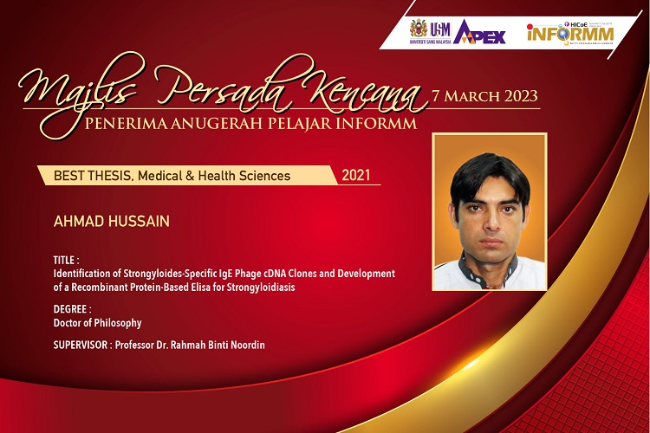
- Image 2 caption: Journal Publication
